Vetty Assignment Solution (Prashant Kuware MCA1004323 BIT Mesra)
Task 1: Git Basics
Steps to complete the task:
- Create a GitHub Repository
  - Log in to GitHub.
  - Click on the "+" icon (top-right) and select "New repository."
  - Enter a repository name (e.g., VettyRepo).
  - Click "Create repository."
- Clone the repository locally
  - git clone https://github.com/PrashantKuware/VettyRepo.git
  - cd VettyRepo
- Create a new branch
  - git checkout -b practical-test
- Create a sample file and add content
  - echo "Hello, Vetty!" > hello.txt
- Add and commit the file
  - git add hello.txt
  - git commit -m "Added hello.txt with welcome message"
- Push changes to GitHub
  - git push origin practical-test
- Create a Pull Request (PR)
  - Go to GitHub.
  - Click on "Compare & pull request."
  - Click "Create pull request."

Task 2: Basic Linux Commands
Steps to complete the task:
- Open a terminal.
ssh prashant@server-ip
- Create a directory
  - mkdir VettyTest
  - cd VettyTest
- Create a script file
  - touch script.sh

- Edit the script to print a message
  - Open the file:
  - nano script.sh
  - Add the following content:
  - echo "Welcome to DevOps!"
  - Save and exit
- Make the script executable
  - chmod +x script.sh
- Run the script
  - ./script.sh

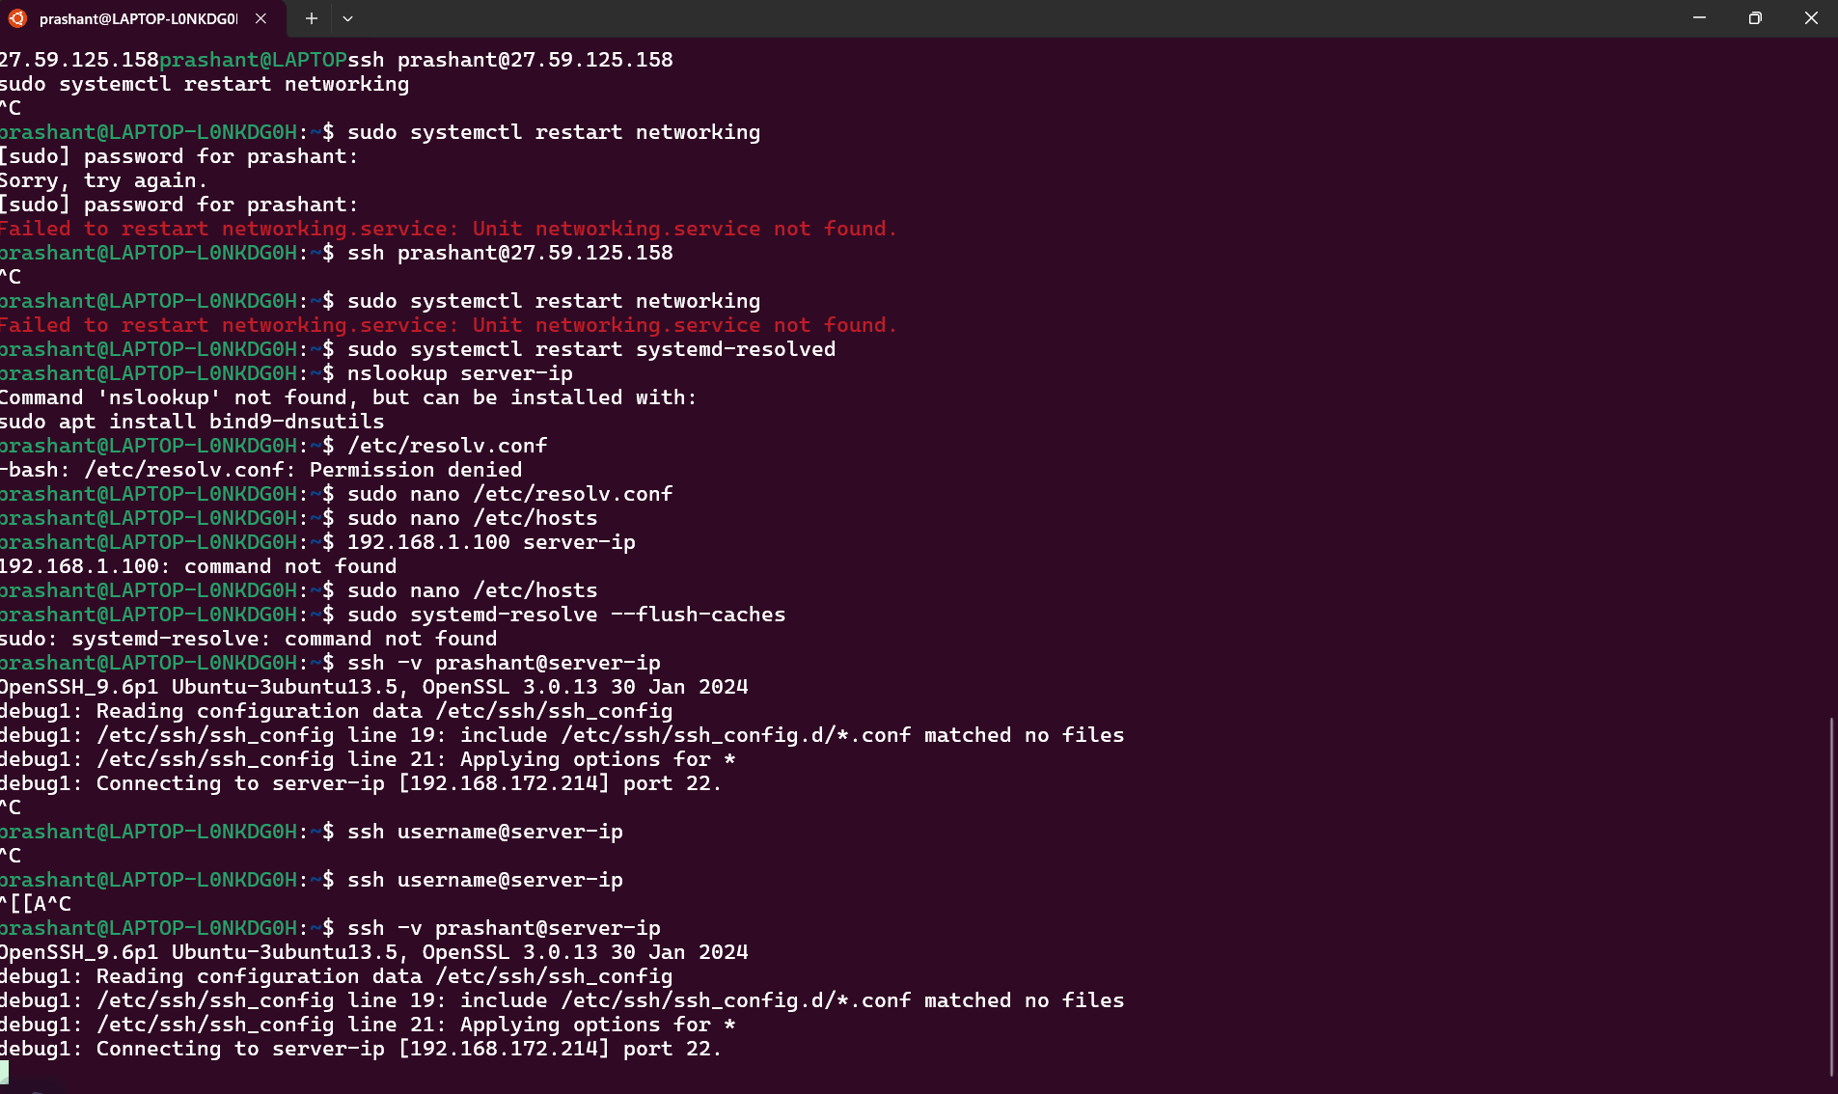
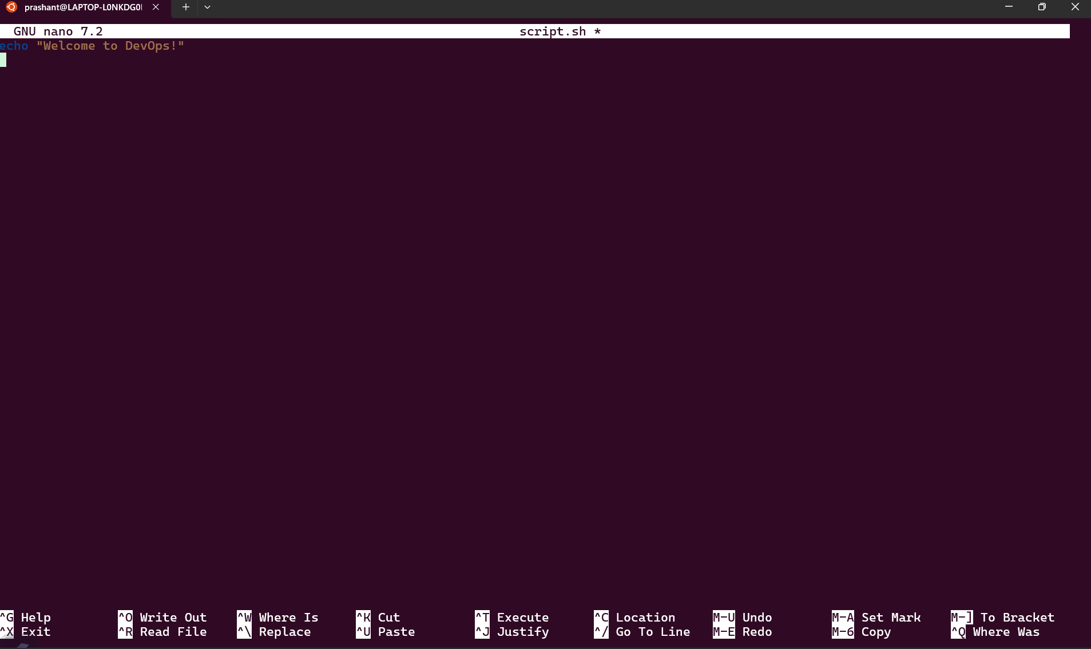
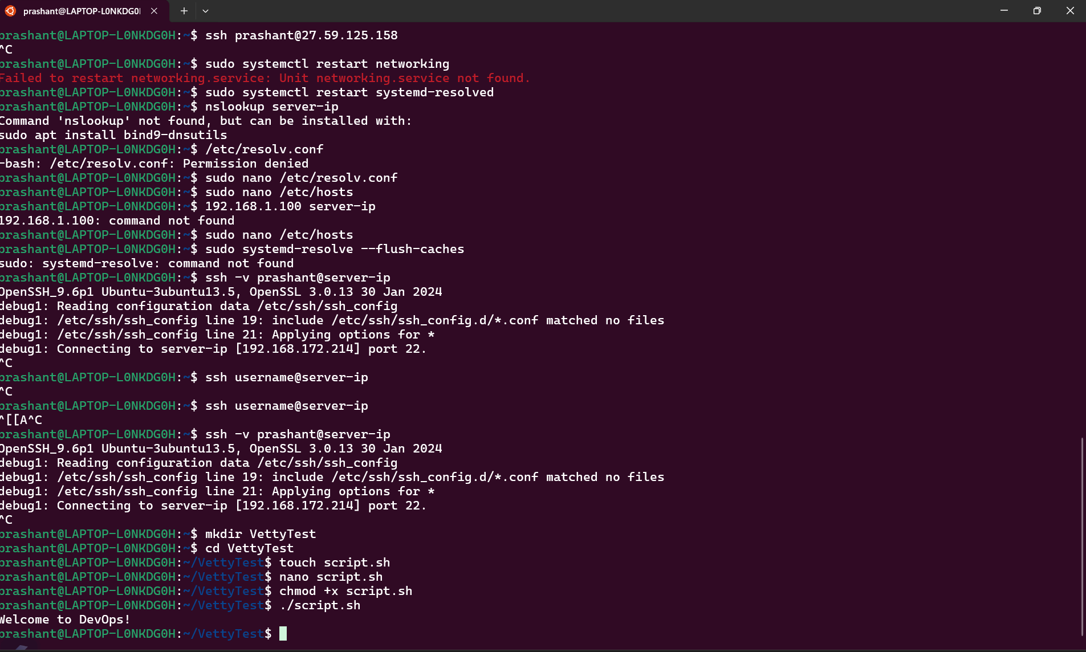
----------------------------------------------------------------------------------------------------------------------------------------------------------
Task 3: Docker Basics
Steps to complete the task:
- Create a directory for the Docker setup
  - mkdir nginx-docker
  - cd nginx-docker
- Create a Dockerfile
  - touch Dockerfile
  - nano Dockerfile
  - Add the following content:
  - FROM nginx:latest
  - EXPOSE 80
  - CMD ["nginx", "-g", "daemon off;"]
  - Save and exit (CTRL + X, then Y, then ENTER).
- Build the Docker image
  - docker build -t my-nginx .
- Run the Docker container
  - docker run -d -p 80:80 my-nginx
- Check if the container is running
  - docker ps
- Open the NGINX default page
  - Open a web browser and go to:
  - http://localhost

